

School of Rock and Media Independent Special School
Careers Education Information and Guidance (CEIAG) Policy
Overview
Students at School of Rock and Media are entitled to CEIAG (Careers Education Information and Guidance) which meets professional standards of practice, which is person centred, impartial and confidential.

All students will receive at least one session with a Careers Adviser

In addition to this, students in all years may request access to the Careers Adviser at any time.

A range of information is available from the Department for Education (DFE) which gives educational organisations clear directives on their duties for providing statutory and impartial careers guidance to young people. This includes:

- Education Act 2011
- Careers Strategy: making the most of everyone’s skills and talents (2017)
- The Baker Clause: careers guidance on technical and vocational options (2018)
- Education (Careers Guidance in School) Act 2022
- The Skills and post 16 Education Act 2022
- Careers Guidance and access for education and training providers (Jan 2023)
- Keeping Children Safe in Education (2024)
- Participation of young people in education, employment or training (2024)

The Gatsby Benchmarks

The 8 benchmarks that School of Rock and Media Independent Special School will work within:

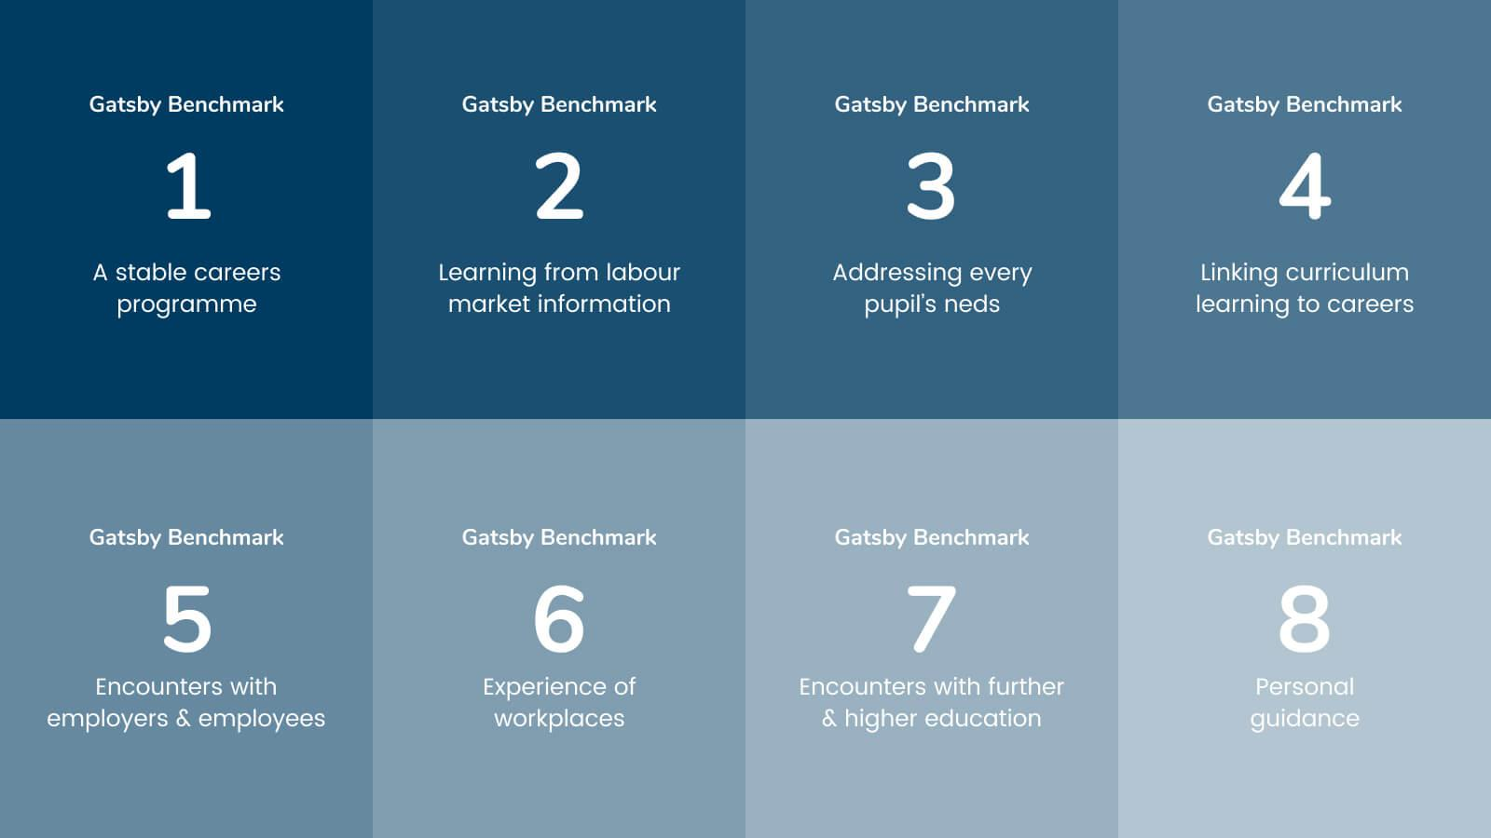

Scope

School of Rock and Media will work in partnership with Skills House CTE and have a service level agreement to ‘buy in’ the service of a qualified and experience Careers Adviser

School of Rock and Media is committed to:

- Responding to the needs of individual learners
- Raising aspirations
- Empowering young people to plan their own future
- Instilling careers resilience
- Providing comprehensive and up to date information and advice
- Actively promoting equality of opportunity and challenging stereotypes
- Preparing our young people to make choices to progress in their chosen pathway
SkillsHouse CTE Responsibilities

- SkillsHouse CTE managers will regularly monitor and review the work carried out by the career’s officers. Discussions will take place with school/college on a termly basis. If any days are lost due to absence, cover will be provided after discussion between SkillsHouse CTE and school management.

- As part of our quality assurance, each careers officer will be observed by a manager on an annual basis, to ensure that careers guidance practice meets national occupational standards.

- It is essential that careers officers keep their professional knowledge updated. As such officers should be given 2 days across the year, based on their overall caseload across a number of organisations, for development purposes and will make up the time to any school/college where this takes place. If the school/college facilitates any internal training and would like the careers officer to take part, this will need to be taken out of the school/college allowance.

- Promoting equality and diversity is imperative to the SkillsHouse CTE service. Bradford Council aims to eliminate discrimination, advance equality of opportunity and foster good relations across all protected characteristics in all its activities including its decision-making, policy development, budget setting, procurement and commissioning, service delivery and employment functions.

- All Bradford Council staff who interact with young people and vulnerable young adults have an enhanced Disclosure and Barring Service check, in line with the Safer Recruitment policies of Bradford Council. The DBS number for each careers officer will be provided to the organisation prior to commencement.

- We will provide opportunities for learners to complete evaluation forms/questionnaires following our interventions, to ensure our service meets the needs of individual young people.

School of Rock and Media Responsibilities:

- Provide a confidential and safe workspace where face to face interviews can be conducted

- Access to internet and printing facilities and access to an outside telephone line, if required

- Notification of any student joining or leaving

- Arrangements for young people who fail to attend personal guidance meetings are put in place, within the contracted time allowance.

- Background information such as attendance records and predicted grades

- Prioritisation of students who require additional support such as young people with EHCPs, Looked After children and other students deemed at risk of becoming NEET

- Careers officers welcome the presence of parents/carers at interviews – this is subject to school/college arranging the appointments

- Changes in personnel relating to key staff with responsibilities for CEIAG need to be notified to the Careers and Transition manager.

The school or college will ensure that their named careers officer is informed of the policies and procedures of the organisation in relation to

- Health and safety
- IT
- Safeguarding
- Outreaching

In the event of a critical incident school will notify the SkillsHouse CTE Careers and Transitions Manager, Liz Hemsley – contact Tel: 07811 504128 ● Email: liz.hemsley@bradford.gov.uk

Signed: Anthony Nicholl-Head of School
Date: September 2026

Date of review:
September 2027

